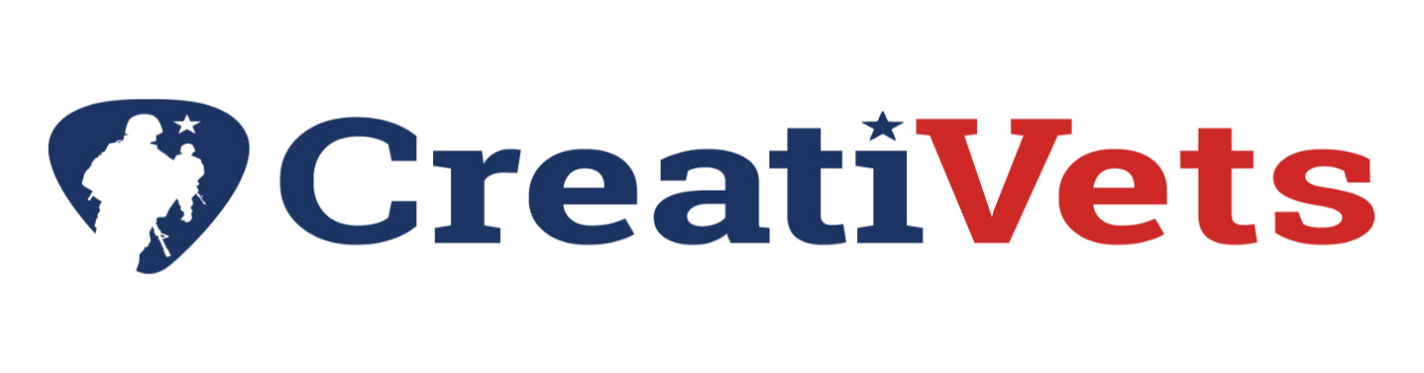
4th Annual Marshall-Putnam Fair
Kids’ Color Run for

Name: _______________________________________________________ Age: ___________
Phone Number: __________________________ Email: ________________________________
Parent/Guardian Signature: _______________________________________________________
Circle T-shirt Size: Youth: XS S M L XL
Adult: S M L XL
If you would like to run in honor of a Veteran, please include their name and military branch below. Limited to one. We will be announcing throughout the Color Run.
_____________________________________________________________
$15 entry fee and t-shirt
$10 entry for run only

Please sign waiver on back.

Come join the fun at the Kids’ Color Run for CreatiVets. Open to kids from 2-102! The run will take place on the designated course in the parking area at the fairgrounds. Go as far as you want or as fast as you want. Those of you who aren’t interested in running, instead of just watching, volunteer to help spread the color on the runners by calling the Fair Office (309-364-2814). Register below by filling out the form and returning it to the Fair Office with your entry fee. $15 entry fee includes an event t-shirt. $10 entry fee to participate in the race without receiving a t-shirt. All proceeds from this event will be donated to CreatiVets. For more information on CreatiVets, please visit their website: creativets.org. Entries may be brought into the fair office or mailed to: Marshall-Putnam Fair P.O. Box 114 Henry, IL 61537.
July 14th – 6 p.m.
Marshall-Putnam Fairgrounds
Henry, Illinois

ALL PARTICIPANTS MUST SIGN THIS FORM IN ORDER TO JOIN THE EVENT.
ASSUMPTION OF RISK, RELEASE AND WAIVER OF LIABILITY, AND INDEMNITY AGREEMENT
PLEASE READ THE FOLLOWING CAREFULLY AND IF YOU HAVE ANY QUESTIONS, PLEASE ASK THEM BEFORE SIGNING THIS DOCUMENT.
In consideration of participating in Marshall-Putnam Fair Kids’ Color Run for CreatiVets on July 14, 2026, I state that I understand the nature of this event and that I am in proper physical condition to participate in such activity. I acknowledge that if I believe that conditions are unsafe, I will immediately discontinue participation in the activity. I willingly and voluntarily agree to the following, or if applicable, as guardian of the participant, I voluntarily execute this Agreement on behalf of my ward and agree to the following:
Assumption of Risk: I understand that this activity I will participate in may be dangerous or have risks. These risks may include serious bodily injury, including permanent disability, paralysis, and death, which may be caused by my own actions, or inactions, those of others participating in the event, the conditions in which the event takes place, or other risks not known to me or not readily foreseeable at this time. I assume full and sole responsibility for any injuries, costs, and/or damages I incur as a result of my participation in this activity.
Medical Condition: I declare that I am physically capable of participating in this activity.
Waiver, Release, and Indemnification: I release, waive, discharge and hold harmless Marshall-Putnam Fair Association and its directors, employees, volunteers, stockholders, other participants, sponsors, and the CreatiVets, from any and all liability, claims, demands, action or causes of action arising out of or related to any loss, destruction, damage or injury, including death, that may be sustained by me or any personal property belonging to me, which may result from participation in this activity. I understand that this Agreement also binds my spouse, heirs, executors, administrators, and assigns.
Photographic Release: I give Marshall-Putnam Fair Association the right, ownership, and interest in any and all photographs, images, video or audio recording of me or my voice made by Marshall-Putnam Fair Association in connection with my participation, which may be used in newsletters, brochures, or presentations to community and civic groups, or organizations or for any advertisement purposes of the Marshall-Putnam Fair.
Other: As a participant, I agree that this Agreement is intended to be broad and inclusive to the extent permitted by the law of the State of Illinois. I agree that in the event that any clause or provision of this Agreement is deemed invalid, the enforceability of the remaining provision will not be affected.
I have read this Assumption of Risk, Release and Waiver of Liability, and Indemnity Agreement, and fully understand its terms. I acknowledge that I am signing this Agreement voluntarily and in doing so I have given up substantial rights. I have signed it without any inducement, and I intend by my signature for this to be a complete and unconditional release of all liability.

_______________________________________________________________________________ ____________________
Signature of Participant Date

______________________________________________________________________________ _____________________
Signature of Parent if child under 18 years/Guardian of Participant Date

______________________________________________________________________________
Relationship to Participant

